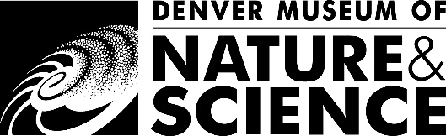

Dear Teachers, Guardians, and Caregivers:
Thank you for signing your students/children up for New Me: Puberty the Denver Museum of Nature & Science’s introductory level biology program about puberty and adolescence.

The following outline gives an overview of all the topics covered during the New Me: Puberty class:

- What is puberty?
- When does puberty typically start?
- What causes puberty to start?
- Changes that occur in both male & female bodies:
- Voice changes
- Growth
- Body hair
- Body shape changes
- Body odor
- Acne
- Emotional changes
- Interest changes (non-sexual)

- Changes that occur specific to male bodies:
- Sperm production
- Erections and ejaculation
- Nocturnal emission
- Changes that occur specific to female bodies:
- Breast development
- Ovulation/egg maturation
- Menstruation and the menstrual cycle

While students receive the same presentation regardless of whether their school chooses to separate classes by sex, we encourage keeping this program co-ed as we have found it facilitates better student discussion and a more mature approach to the subject matter. We have designed the class accordingly. We provide an excellent knowledge base which teachers and families are encouraged to extend.

Questions surrounding puberty are encouraged and are answered in a scientific, tactful manner or are redirected to the classroom teacher of student’s family if they are beyond the scope of the outline.

Topics not covered in this class include sexual intercourse, gestation and childbirth, abortion, contraception, sexually transmitted infections, sexuality, or gender and identity. The focus on this class is the basic biology and anatomy of developing reproductive systems, not the act of reproduction itself.

The museum does not customize this program for each class. We respect that individuals have differing views and values on how to educate students regarding puberty and trust teachers and family members to decide whether this program is the right fit for your child/children.

Sincerely,

Virtual Programs
Denver Museum of Nature & Science

